Boolean Logic Test

1. Complete the following truth table.

|  |  |  |  |  |  |  |  |
| --- | --- | --- | --- | --- | --- | --- | --- |
| **A** | **B** | **AND** | **OR** | **XOR** | **NOT A** | **NAND** | **NOR** |
| 0 | 0 | 0 | 0 | 0 | 1 | 1 | 1 |
| 0 | 1 | 0 | 1 | 1 | 1 | 1 | 0 |
| 1 | 0 | 0 | 1 | 1 | 0 | 1 | 0 |
| 1 | 1 | 1 | 1 | 0 | 0 | 0 | 0 |

1. Complete the following truth table for the Boolean expression

**A** XOR (**B** OR **A**)

|  |  |  |  |
| --- | --- | --- | --- |
| **A** | **B** | **(B OR A)** | **A XOR** (B OR A) |
| 0 | 0 | 0 | 0 |
| 0 | 1 | 1 | 1 |
| 1 | 0 | 1 | 0 |
| 1 | 1 | 1 | 0 |

1. Create a truth table for the Boolean expression

**A** AND (NOT **B** OR **A**)

|  |  |  |  |  |
| --- | --- | --- | --- | --- |
| **A** | **B** | NOT **B** | **(**NOT **B** OR **A)** | **A** AND |
| 0 | 0 | 1 | 1 | 0 |
| 0 | 1 | 0 | 0 | 0 |
| 1 | 0 | 1 | 1 | 1 |
| 1 | 1 | 0 | 1 | 1 |

1. Create a logic diagram for the following Boolean expression.

(**A** AND **B**) OR NOT **A**

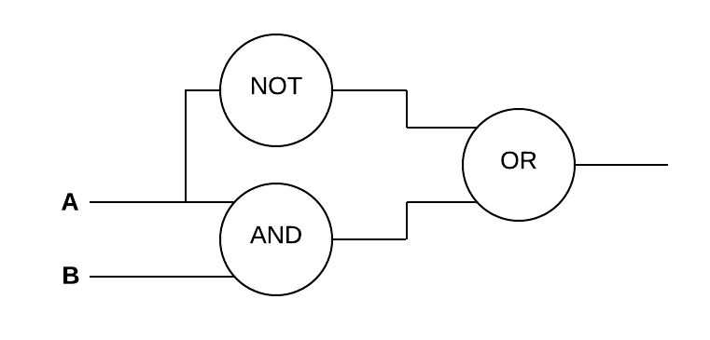

1. Create a logic diagram for the following Boolean expression.

(**A** AND **B**) OR (**A** XOR **B**)

